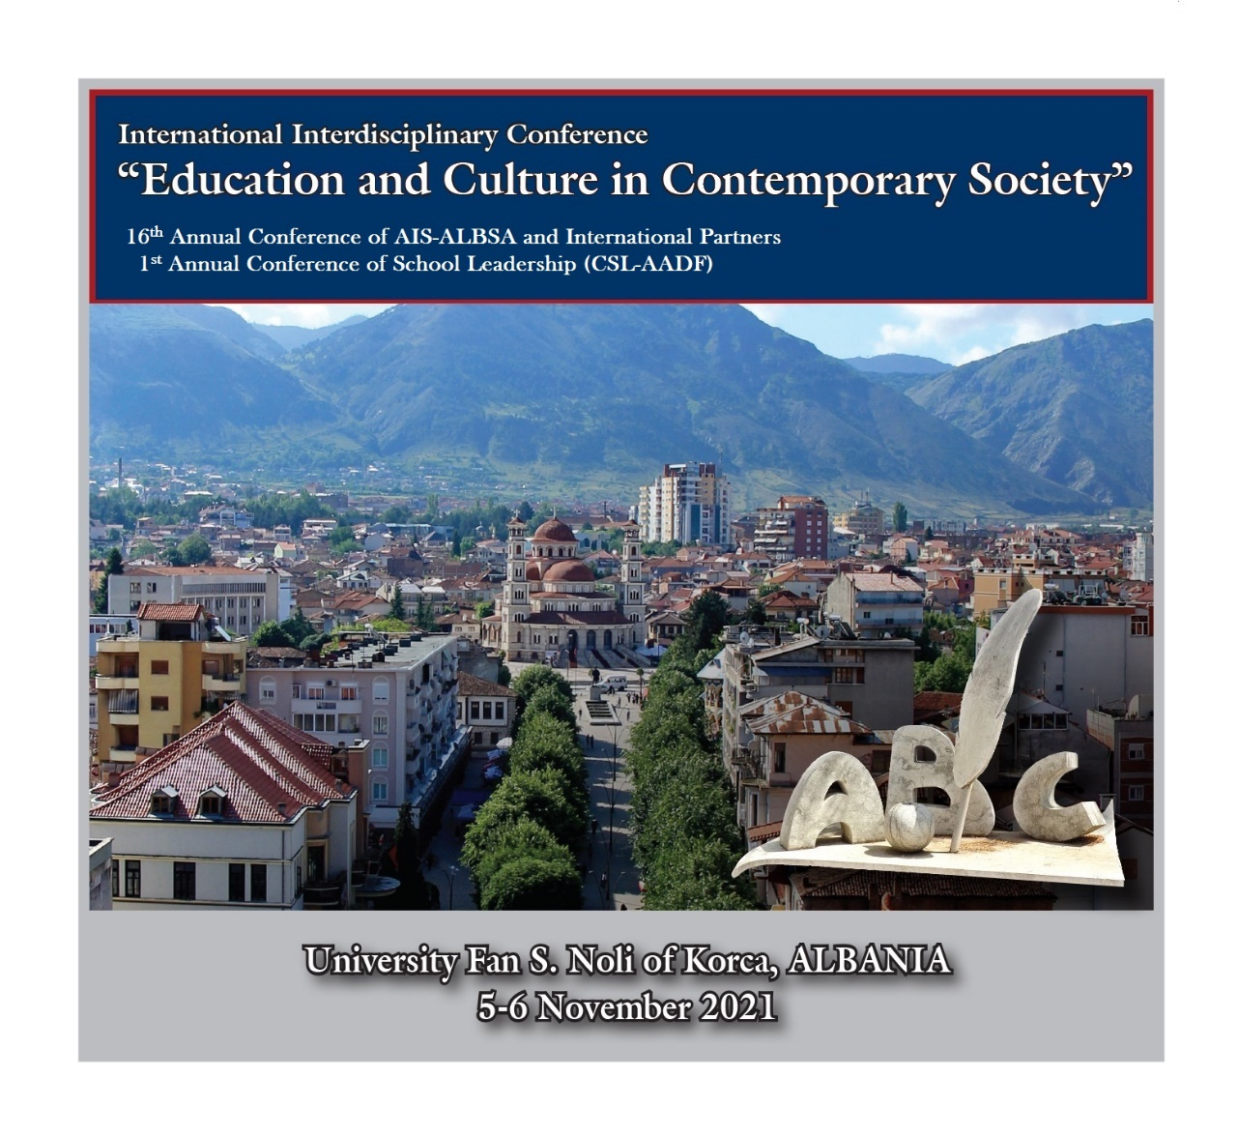

16th International Interdisciplinary Conference:
“Education and Culture in Contemporary Society”
&
1st Annual Conference of School Leadership
(CSL – AADF)

Co-Presence
Online
Or Hybrid

- 210 papers and presentations
- 330 authors, Co-authors, and Contributors
- 25 Countries
- Plenary Session, Special and Joint Session
- Award for Excellence in Research and Practice

Organizing Institutions:

University Fan S. Noli of Korca, Albania
Albanian Academy of Science, ALBANIA
CSL – AADF Center for School Leadership, ALBANIA
University of Gjilan Kadri Zeka, KOSOVO
AAB College, KOSOVO
University Aleksander Moisiu Durres, ALBANIA
University of Prizren Ukshin Hoti, KOSOVO
University of Mitrovica Isa Boletini, KOSOVO
Southeast European University, North MACEDONIA
Institute of Science and Technology - INSI, KOSOVO
&
International Sociological Association, ISA
Albanian Institute of Sociology, AIS - Albanian Sociological Association, ALBSA

Place & Time:
University Fan S. Noli of Korca, Albania
5-6 November 2021

I.
SCIENTIFIC COMMITTEE AND LOCAL ORGANIZING COMMITTEE

Conference Scientific Committee
Chairs of the Conference:
Akad. Prof. Dr. Skender GJINUSHI - Chairman of the Albanian Academy of Science
Prof. Dr. Dhimitri BELLO - Rector, University Fan S. Noli of Korca

Abdylmenaf BEXHETI - Southeast European University, North MACEDONIA
Agri SOKOLI –St. Luis International School Milan, ITALY
Aida GOGA - University of Tirana, ALBANIA
Ali PAJAZITI – Southeast University of Tetovo, North MACEDONIA
Alush MUSAJ - University of Mitrovica Isa Boletini, KOSOVO
Arta SAKJA – Albanian University, ALBANIA
Bajram KOSUMI - University Kadri Zeka of Gjilan, KOSOVO
Besim Gollopeni – UMIB & Albanian Institute of Sociology, Kosovo
Blerina HAMZALLARI - University of Tirana, ALBANIA
Brunilda ZENELAGA – ALBSA; University of Tirana, ALBANIA
Bujar DEMJAHA – AAB College, KOSOVO
Christiana CONSTANTOPOULOU, ISA-RC14 & Panteion University, Greece
Dukagjin LEKA - University Kadri Zeka of Gjilan, KOSOVO
Doreta KUÇI TARTARI - University Aleksander Moisiu Durres, ALBANIA
Genti KRUJA – Beder University College, ALBANIA
Geron KAMBERI - Center for School Leadership, CSL-AADF, ALBANIA
Griselda ABAZAJ - University Aleksander Moisiu Durres, ALBANIA
Irena NIKAJ - University Fan Noli of Korca, ALBANIA
Ismajl BAFTIJARI - Institute for Science and Technology (INSI), KOSOVO
Ismet TEMAJ - University of Prizren Ukshin Hoti, KOSOVO
Jasminka LAŽNJAK - University of Zagreb, CROATIA
Jonida LAMAJ - Albanian American Development Foundation, ALBANIA
Koby Gutterman - Kibbutzim College of Education, Technology and the Arts; Tel-Aviv, ISRAEL
Kseanela SOTIRIFSKI - University Aleksander Moisiu of Durres, ALBANIA
Lea YPI - London School of Economics and Political Science, United Kingdom
Leke SOKOLI - Albanian Institute of Sociology (AIS) & UAMD, ALBANIA
Marios VRYONIDES, ISA-RC04 & European University Cyprus, Cyprus
Migena KAPLLANAJ – University Marin Barleti Tirana, ALBANIA
Monika HASANI - University Ismail Qemali Vlora, ALBANIA
Roland ZISI - University Ismail Qemali Vlora, ALBANIA
Romina Gurashi - Sapienza University of Rome, ITALY
Rumiana Jeleva - Institute of Philosophy and Sociology of BAS, BULGARIA
Rumiana Stoilova - Bulgarian Sociological Association, BULGARIA
Sabri Kiçmari – ALBSA; University of Pristine, KOSOVO
Sarina Bakić - University of Sarajevo, BOSNIA and Herzegovina
Sergiu BALTATESCU - University of Oradea, ROMANIA
Sonila DUBARE - University of Florida, USA
Vahidije Kadiu - Center for School Leadership, ALBANIA
Venera LLUNJI – AAB College, KOSOVO

Coordinator of partner institutions:
Leke SOKOLI - Albanian Institute of Sociology (AIS) & UAMD

Conference Coordinators:
Benita STAVRE - University Fan S. Noli of Korca, ALBANIA
Geron KAMBERI - Center for School Leadership, CSL-AADF, ALBANIA

Chair of the Local Organizing Committee:
Petrika PETRO – University Fan S. Noli of Korca, ALBANIA

Chair of the conference Secretary:
Elda KUTROLLI, Albanian Institute of Sociology, AIS

Conference Program

Place and time
University Fan S. Noli of Korca, Albania
5-6 November 2021

Keynote speakers:
Prof. Lea YPI
London School of Economics and Political Science, United Kingdom

Prof. Koby Gutterman
Kibbutzim College of Education, Technology and the Arts Tel Aviv, ISRAEL

1st Conference Day
5 November 2021, 10.00

Registrations (Online and in person):
Registration Desk: 5 November 2021, beginning 08.00
University Fan S. Noli of Korca, Albania
Campus of the Faculty of education
[Conference program, conference book/proceedings, journals, and detailed information for the participants]

Opening Ceremony and Welcome address
Conference Hall
University Fan S. Noli of Korca, Albania: 10.00-11.30

Chairs/moderators:
Prof. Asoc. Dr. Benita STAVRE - UNIKO Deputy-Rector for Research and Projects

Welcome to Albania and UNIKO
Prof. Dr. Dhimitri BELLO - Rector of University Fan S. Noli Korca, Albania

Welcome address:
Akad. Prof. Dr. Skender GJINUSHI, Chairman of the Albanian Academy of Science

Welcome to the 1st Conference of School Leadership
Geron KAMBERI, Executive Director of Center for School Leadership (CSL)

Representatives of the Organizing Institutions:
Prof. Bajram KOSUMI - Rector, University Kadri Zeka of Gjilan, KOSOVO

Prof. Dr. Bujar DEMJAHA – Rector, AAB College, KOSOVO

Prof. Dr. Kseanela SOTIRIFSKI – Rector, University Aleksander Moisiu Durres - ALBANIA

Prof. Dr. Ismet TEMAJ, Rector - University of Prizren Ukshin Hoti, KOSOVO

Prof. Dr. Alush MUSAJ, Rector - University Isa Boletini of Mitrovica – KOSOVO

Akad. Prof. Dr. Abdylmenaf BEXHETI, Rector - Southeast European University, North MACEDONIA

Ismajl BAFTIJARI, Director of the Institute for Science and Technology (INSI), KOSOVO

Besim GOLLOPENI, President of the Balkan Sociological Forum; University Isa Boletini of Mitrovica – KOSOVO

Award:
Prof. Dr. Leke SOKOLI - UAMD & Albanian Institute of Sociology (AIS)
Award for Excellence in Research and Practice

Agreement:
Albanian Academy of Science - Albanian Institute of Sociology
Akad. Prof. Dr. Skender GJINUSHI - Chairman of the Albanian Academy of Science
&
Prof. Dr. Leke SOKOLI - General Director of the Albanian Institute of Sociology (AIS)

From Korca - Albania to Gjilan-Kosovo
Next International Conference:
“The role of Technology in the Shaping of Society”
17th International Interdisciplinary Conference of AIS-ALBSA and other Partners
&
2nd Conference of the School Leadership
University Kadri Zeka of Gjilan, KOSOVO
11-12 November 2022

Presentation of the Conference Program
Prof. Dr. Irena NIKAJ, Conference Coordinator; President of the Albanian Sociological Association (ALBSA); UNIKO

1st Annual Conference of School Leadership (CSL – AADF)

Keynote speaker:
Prof. Koby Gutterman - Kibbutzim College of Education, Technology and the Arts Tel Aviv, ISRAEL
Campus of the Faculty of Education, University Fan S. Noli of Korca
5 November 2021: 12.00

Presentations: Four Sessions of the CSL Conference
5 November 2021: 12.30
Conference Rooms: Faculty of Education

16th International Interdisciplinary Conference
“Education and Culture in Contemporary Society”

Keynote speaker:
Prof. Lea YPI
London School of Economics and Political Science, United Kingdom

Campus of the Rectorate, University Fan S. Noli of Korca
5 November 2021: 12.00

“The Universe of Gjergj Fishta”
Special Session on 150 Anniversary
Chair: Prof. Irena NIKAJ
President of the Albanian Sociological Association (ALBSA); & UNIKO
Campus of the Rectorate, University Fan S. Noli of Korca
5 November 2021: 12.30

Presentations of the first day: Conference Thematic Sessions (TS01-TS14)

2nd Conference Day: 20 March 2021

Presentations:
Conference Thematic Sessions of the second day (ST01-ST14)

Conclusions, Closing Ceremony, and Certificates “For participating and presenting the Paper” (After the last presentation of each Conference Session)

