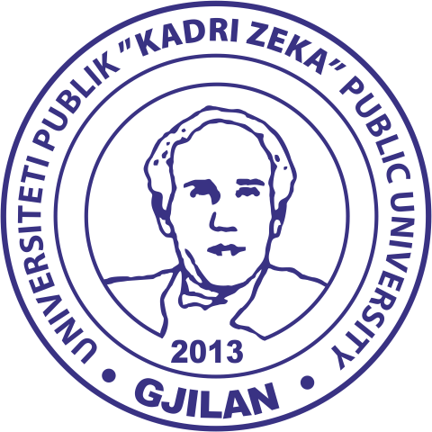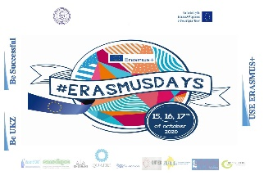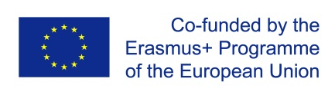

ERASMUS+ INFO DAYS
15^{th,} 16th and 17th of October 2020

A G E N D A

During the three Erasmus Days, University “Kadri Zeka” will organize different activities:
15th October 2020
10:00-10:30- Promotion of Capacity building projects, where our university has been participating
10:30-11:00 - Spreading the word - Staff and students’ presentations of best practices in the university corner, with their experience in participating in Erasmus+ activities;
11:00-12:00- Erasmus+ as an open door for internationalization; development and human capacity building;

16th October 2020

10:00-11:00 -Be UKZ, Be Successful, USE Erasmus+ (Presentation of UKZ best practices)
All day long: Erasmus+ Fair on 15, 16, and 17;

